**Machine Learning : Multi-class Classification**

**Multiclass Classification**

* **More than two classes**
  + **KNN?**
    - **Still just vote**
  + **K-Means?**
    - **Still just vote**
  + **Decision Tree?**
    - **Entropy(S) = $-p_{+}log_{2}p_{+}-p_{-}log_{2}p_{-}$**
    - **Entropy(S) = ${\sum_{Cϵclasses}{-p_{c}log}}_{2}p_{c}$**
    - **Gain**
  + **Perceptron much more difficult**

**One-versus-all (one-vs-rest)**

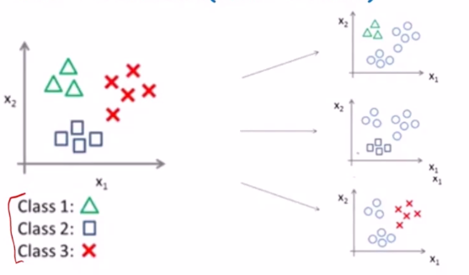

* **Pose multiclass problems as a set of binary class classification problems**
* **For each binary classification problem, we will only focus on one class calling that the positive class and the rest the negative class**
* **Pick the classifier with the most confident with its answer**
* **Requires classifiers to report probability of classification (confidence)**

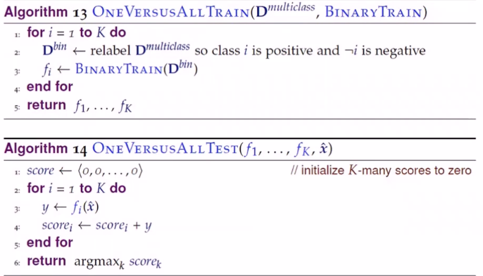

**All-versus-all (one-versus-one)**

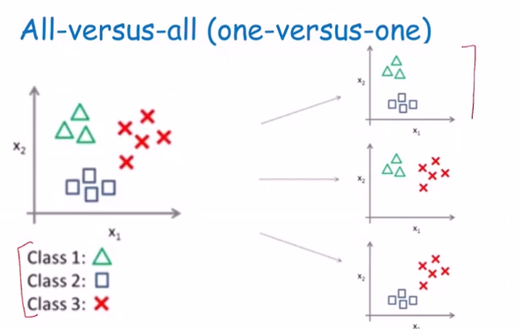

* **Instead of pitting one against the rest**
* **We train binary classifier for each pair of concepts**
* **Run like a tournament**
* **Pro:**
  + **No class imbalance**
* **Con**
  + **A lot of binary classifier to train**
  + **C(k,2)**
* **At the end class with the most votes is given as the label to the data point**

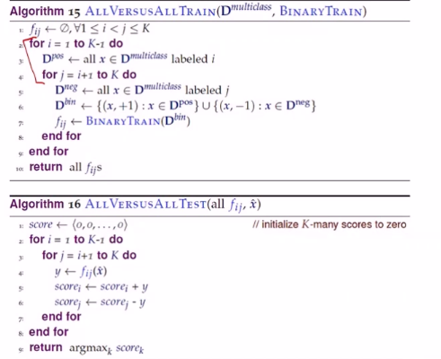

**Binary Tree of classifiers**

* **Pro**
  + $log_{2}k$**classifiers**
 $Con$

 + **Accuracy depends on ordering of tree**

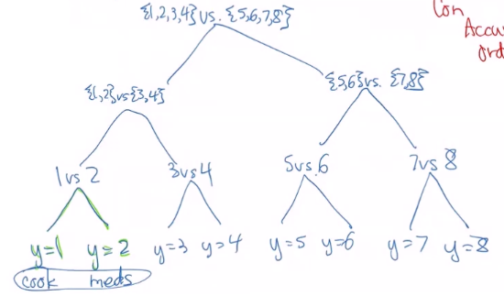

**Overrun by hyperparameters**

* **Manual**
* **Grid Search**
* **Random Search**

**Bayesian Optimization**

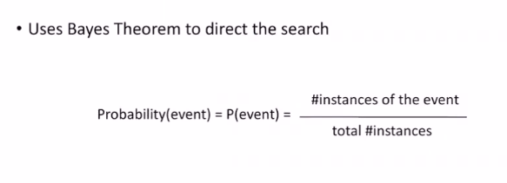

**Sources of probabilities**

* **Frequency**
* **Reference class – the space of possible events that we are considering as the denominator of the probability**
* **Probability not always intuitive**
* **Follow axioms to get the result you need**

**Axioms of probability**

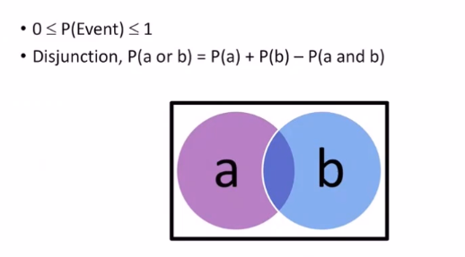

* **Disjunction either a or b no overlap**

**Conditional probability and conjunction**

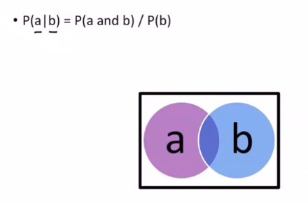

* **Conjunction overlaps a and b**

$P\left(b\right)≥0$

$P\left(class \right| features)$

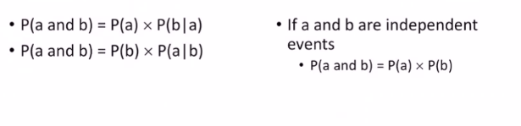

**Bayes Rule**

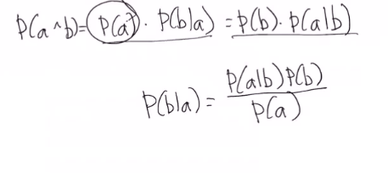

* **We can use Bayesian optimization to come up with a set of hyperparameters that performs well without computational expense**

